**Chapter 1: LIFTING THE HOOD**

**Topic – 1: Switches, Transistors & Memory**

**Early History**

* Light’s **ON/OFF** switch inspired development of **memories** in computers.
* Type of switches used to tell machine’s state is irrelevant (**mechanical**, **electrical**, **steam-powered**, **hydraulic** etc).

**Switches & Memory**

* **Memory:** A **pattern retained** by the elements in machine.
* **Relay:** Mechanical switch controlled by **electricity**.
* **Output** is decided by the **electrical contacts** (**patterns**) made by those **relays**.
* Also, memory was made with **vacuum tubes** earlier.
* Nowadays, it is made using **transistor switches**.

**Transistors**

* **Transistors:** Tiny silicon crystal switches.

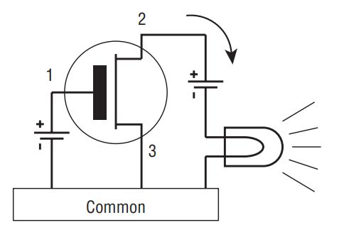

* When electricity is supplied to **pin 1**, it flows through **pin 2 & 3** to activate the output bulb.
* Its simple representation would be as shown below.

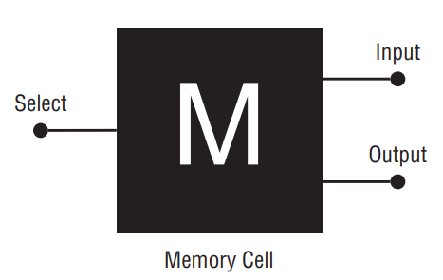

* Actually, **transistors** work with **diodes** & **capacitors**.
* **Diode:** A semiconductor device used to make electricity flow in **one direction**.
* Earlier, transistors & these components were connected via **wires**.
* Transistor & these components together are known as a ***memory cell***, as we saw in previous diagram.

**Voltage**

* We pass a very **minimal voltage** which is enough for circuit & avoids **overheating**.
* In memory cell, voltage is **constantly** always applied on **select** **pin**.
* If we pass it to **input pin** too, then voltage comes at the **output pin**.
* This level of voltage applied to any unit is **consistent** & magnitude **doesn’t** change.
* Capacity of this unit is a **bit**.

**Silicon Chips**

* Early transistors were made from **silicon** or **germanium** crystal chips.
* Their sizes were **1/8th** of an **inch**.
* These days, the size of crystal **remains same** but **transistor** size has **shrunk** a lot.
* So, **more** transistors are packed into **one** crystal chip.

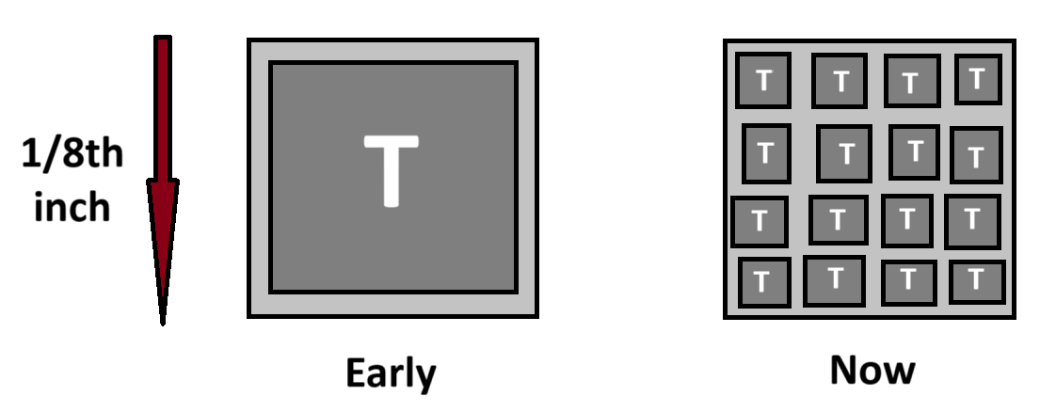

* Early chips were very **fragile** like **chewing gum**.

**Evolution Of Chip Capacity**

* Chip capacity has evolved by a **factor** of **4**.
* For example, **16K** **chip** (**16,000** transistors) then becomes **64K chip**.
* This is because the length of transistors is **halved** in current generation, creating space for **3 times more** transistors to be added.

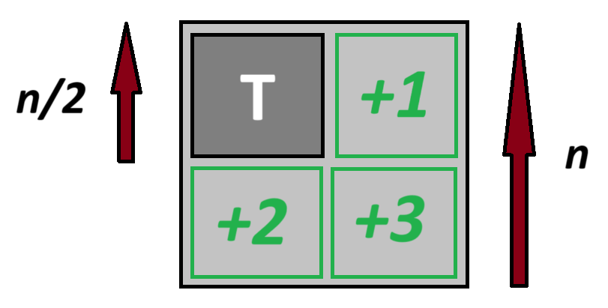

* Transistor sizes are **"halved"** because that’s the **minimum shrinking size** to properly fit more transistors over whole chip.
* But physicists warn reaching the **limit for shrinking** transistor sizes to a size where it becomes difficult passing **electrons** through them.

**Serial Access Device**

* Memory before being evolved to be stored in **silicon chips**, were stored in **electromagnetic devices** called ***serial-access device***.
* They had rotating **magnetic piece** which stored data to the **bit** behind **magnetic sensor** it was crossing in circumference.

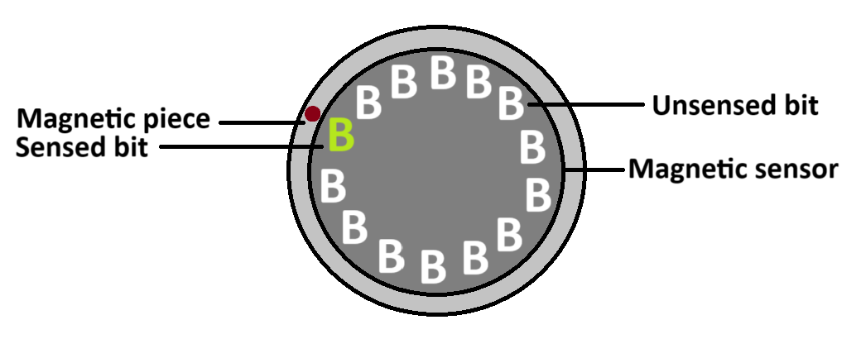

* **Hard drives** can be roughly called as **serial-access devices**.

**Random Access Memory**

* All **bits** in **RAM** have a **unique address** for itself.
* Figure below shows **circuit diagram** of a **RAM chip**.

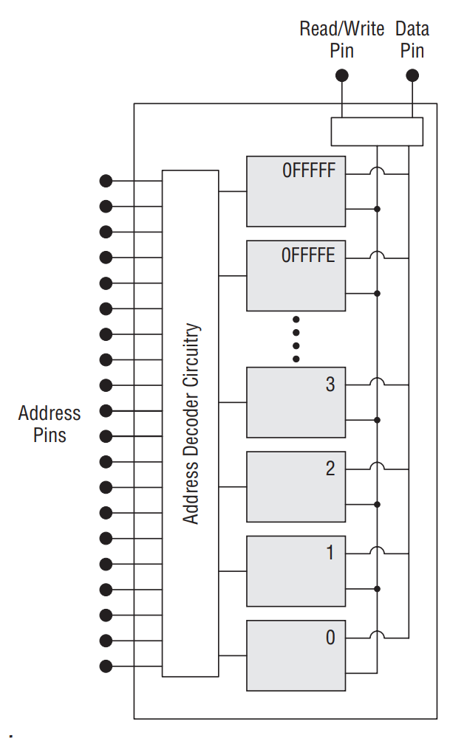

* ***Address pins*** carry **binary address code**.
* If a pin carries **1**, means a certain **voltage** is present there.
* Though the value of voltage **varies** from machine to machine, most use **5V** in them.
* So, when the **binary pattern** made by address pins is decoded, it lights up the matching memory cell with **5V**.
* These memory cells can be both **read** or **written** as clearly evident by presence of a ***read/write pin***.
* When the address pin matches to given input, data pin is light up with 5V.

**Memory Access Time**

* Typical memory chip access time nowadays is **30 nanoseconds**.
* The **less** the **memory access**, the **better** the **performance**.

**Size**

* The way to **organize memory chips** depends on **how** we want to organize our information.
* When it comes to technical details, memory is measured in **bytes**.
* For units like **word**, **double** **word** or **quad word** etc, we mean that bytes are arranged **consecutive**.
* Similarly for a **byte**, **eight bits** are **consecutive**.

**1 byte character = 8-bit binary code**

* Computers nowadays are just increasing in processing **multiple bytes** at a time.
* Though having capacity of typically a **billion bits**, RAM chips **don’t** have more than **4 data pins**. Some even have just **1**.
* For example, take a look at the diagram below.

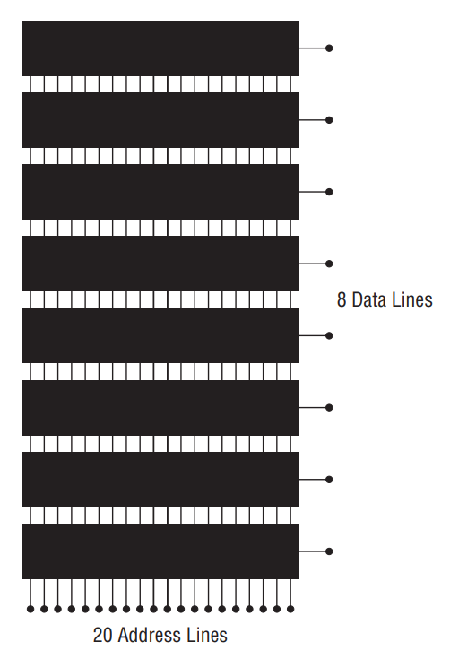

* This diagram shows **parallelly connected** RAM chips.
* Number of **address lines** shows how many **unique addresses** it contains (**220** here).
* And number of **data lines** shows its **capacity** (**8-bit** here).
* Nowadays, per address **multiple bits** are being stored.
* Refer to figure below, showing **old-style** on **left** & **new-style** on **right**.

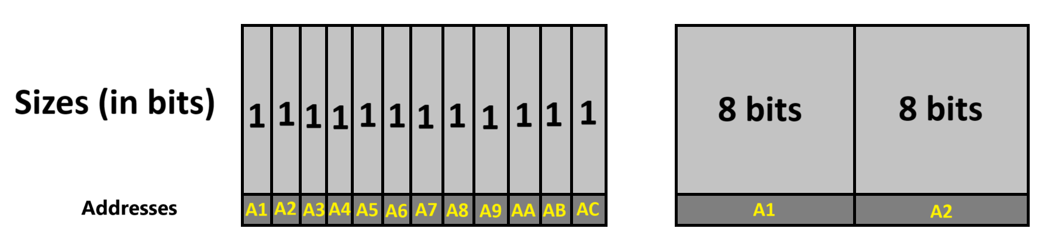

* **DIMM:** Dual Inline Memory Modules
* **DIMMs** keep all memory chips **together**, **not** requiring each one to be plugged separately like old times.
* It looks as shown below.

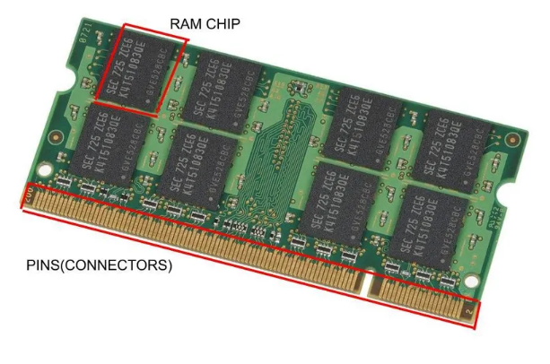

* They usually come in **pairs**, each address with capacity of **32-bits** (total **64-bits**).
* This means that processors fetches & processes **64-bits** (**8 bytes**) at a time.
* ***\*Tolkien’s “Lord Of The Rings” reference…\****
* But each **byte** in **memory** has its own address, as per the convention.
* This means that **64-bit** CPU accesses **8 bytes** starting from the **requested byte**.
* Capacity of each module is around **512 MB** or **1-2 GB**.
* **How** memory chips are arranged in the system affect the **speed** of reading, writing or accessing memory in general.
* Basically, reading & writing is done by these chips.